**Module 6:**

# PREDICTIVE MODELLING USING RS DATA - READER

Welcome to the ML4EO Module 6 on Predictive Modelling using Remote Sensing data. This module heavily builds on the skills and workflows presented in our previous module 5.

**Predictive modeling** using remote sensing data is the analysis of Earth Observation (EO) data with statistical or machine learning techniques to make predictions about environmental conditions or environmental variables - in future or generally in places, where in-situ observations are not available. Compared to causal modeling, where the relationship between input variables and outcomes are well-understood, predictive modelling relies on indicators and proxy-variables, whose relationships are sometimes unclear. Nevertheless, the assessment of these models can give valuable insights into the relationship between input and output variables, improve our understanding of human-environmental systems and help to identify the key factors that influence them.

**Section 6.1** of this reader will provide a short overview on **typical use-cases**, where machine-learning techniques are used to analyze (not-only) EO data; enabling us to map different variables that characterize human-environmental systems. For example, we will explore the spatial and temporal variations of land cover and land-cover changes, and biophysical properties in urban, agrarian, or aquatic ecosystems.

In **section 6.2** we will go into more detail with popular machine-learning algorithms (incl. CNNs, Random Forests, SVMs), that are often used to analyze EO data. We will discuss the **advantages and disadvantages** of these methods in terms of the data sources used (and associated preprocessing), the requirements necessary to train machine learning (ML) models using EO data, as well as further application-specific requirements.

Finally, **section 6.3** provides key concepts from the field of *transfer learning*. Transfer learning in the field of machine-learning based Earth Observation refers to the process of using pre-trained models on Earth Observation data sets, and applying the knowledge learned to other data sets or use-cases. This technique is used to reduce the amount of training data required to train a model and improve its accuracy for a specific task. By using transfer learning, a model can leverage the information gained from previous training to offer better predictive models for new applications. Overall, transfer learning is an effective technique that saves time and resources for training models.

By the end of this training module, we will have gained an overview on how different machine-learning approaches can be used to analyze EO data and predict outcomes that support a wide range of applications. We will have gained practical skills in optimizing the features, the machine-learning models, and their outcomes with regard to different use-cases.

Participants will:

* Gain understanding about the typical use cases at the intersection of EO and ML
* Understand the pros and cons of ML algorithms like Random Forests, Support Vector machines, and deep CNNs to analyze EO data
* Be able to identify the data requirements for different use-cases
* Understand the pros and cons of ML algorithms like CNNs, Random Forests and Support Vector machines to analyze EO data
* Understand common feature engineering and model training methods for EO data-based models
* Understand the concept of transfer-learning in the EO data space and recognize common foundational models used to fine tune EO data-based predictive models.

# 6.1 Introduction to use cases in predictive modelling using EO/RS data

## Introduction

Over recent decades, remote sensing applications have been developed that use machine-learning (ML) algorithms to produce insights using EO/RS data sources. They allow to monitor large, remote and often inaccessible areas with a consistent methodology. Remote sensing applications based on ML are nowadays indispensable for environmental planning and monitoring, the assessment of food production and the mitigation of environmental risks and damages.

ML applications in remote sensing predominantly employ three types of algorithms: Support Vector Machines (SVM), Random Forests (RF), and deep neural networks (deep learning). The tasks emanating from these model types can generally be grouped into “Classification”, “Regression”, “Clustering” and “Segmentation” (Table 1).

Table 1: Tasks for ML algorithms in remote sensing.

|  |  |
| --- | --- |
| Task | Meaning |
| Classification (EO) | Assigning categorical “class” labels to single image pixels.  Examples: “agriculture”, “urban”, “forest”, or in case of event detection: “deforested”, “burnt”, “tilled”. |
| Regression | Assigning a continuous predicted value to single image pixels.  Examples: leaf area index [-], soil moisture [cm³/cm³], vegetation height [m] |
| Clustering | Assigning categorical labels to image pixels which group pixels by similarity of their band values. Also known as unsupervised classification.  Used in Exploratory Data Analysis (EDA), e.g., visually identify spatial patterns of pixels with similar band values.  Examples: Cluster numbers 1, 2, 3, 4, …, n |
| Image Segmentation,  Object delineation | Grouping pixels into homogeneous geospatial-objects (“segments”).  Examples: delineation of field boundaries, city blocks, shapes of rivers and lakes. |
| Semantic segmentation | Assigning a (semantic) “class” labels to images pixels, based properties of the entire segment it relates to. e.g., “building”. |
| Instance Segmentation | Assigning a segment id to images pixels, e.g., for each detected building |
| Panoptic Segmentation | Combines semantic with instance segmentation and differentiates between class and segment id. |

## Classifications

Classification is the labeling of image pixels or image segments with categorical values and probably the most frequent use of ML algorithms in remote sensing. Classifiers are used to:

* map land-cover and land-use, e.g., crop types, tree-species, infrastructure types, biomes
* map agricultural management systems, e.g., crop-rotations and tillage-systems (“no-tillage”, “reduced impact tillage”, “conventional tillage”)
* detect event-like changes, e.g., deforestation, floods, damages after earthquakes, active fires and burning scars.

The online map viewer of the Digital Earth (DE) Africa project[1] allows you to visualize exemplary classifications, e.g., cropland mask and the land-cover classes from ESA WorldCover 2020 (Figure 1).

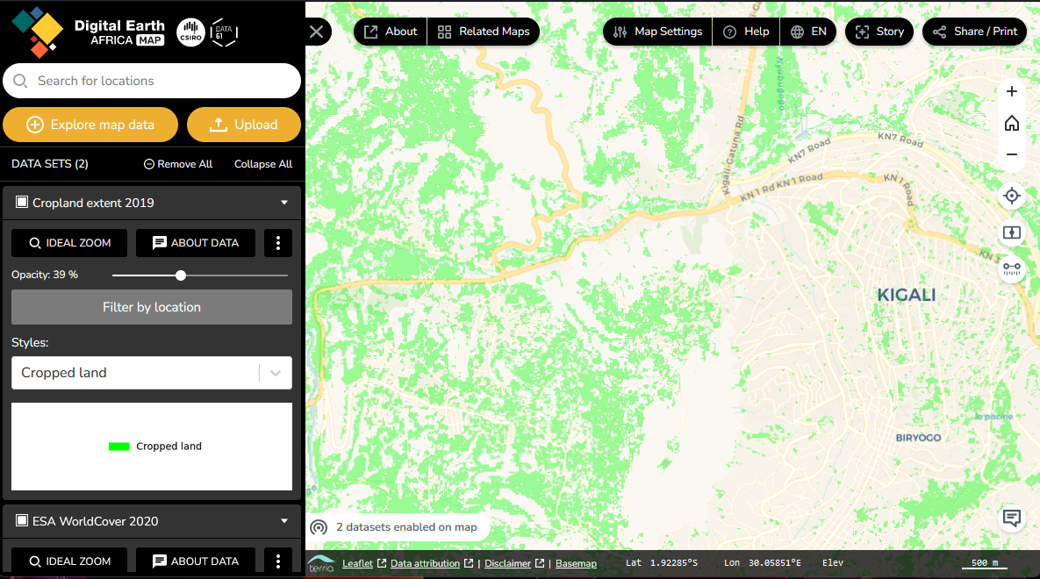

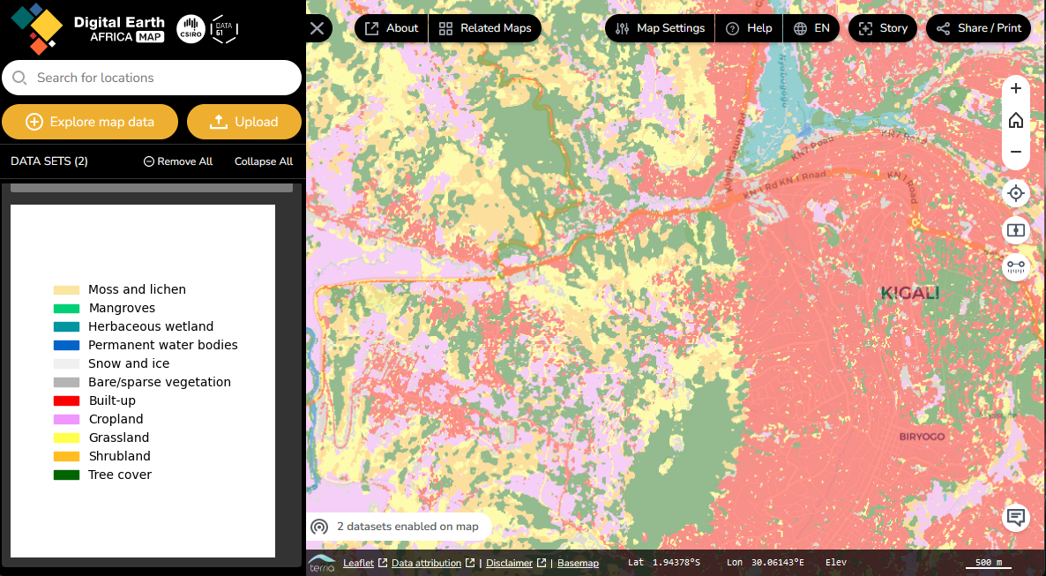

Figure 1: Digital Earth Afrika Web Viewer with (top) Cropland Mask 2019 and (bottom) ESA WorldCover 2020 landcover classification. Source: https://maps.digitalearth.africa

Cropland masks are an important starting-point to create higher level products that assist with managing food insecurity, such as cropping watering intensities, crop types, or crop productivity

* What do you think – is this a good cropland mask? Can you identify places where the cropland mask is likely in-correct or, on the contrary, wrong?

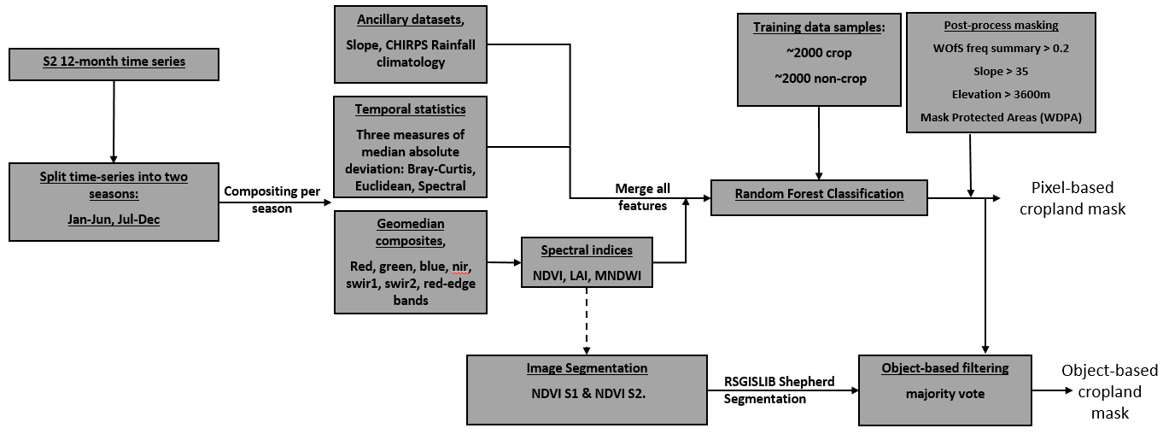

Figure 2: Workflow of Digital Earth Africa to generate the cropland mask.

The workflow to create the DE Africa Cropland mask 2019 (Figure 2) is typical for many remote-sensing workflows. It uses data from different sources: (i) a time-series of Sentinel-2 observations, (ii) a slope dataset derived from the Copernicus Digital Elevation Model[2], and (iii) CHIRPS[3] rainfall data. All these *input feature*s are linked to the presence or absence of cropland: Cropland management influences what becomes visible in the Sentinel-2 data; crops are preferably cultivated on flat terrain that is easier to manage and has a reduced risk for soil erosion; and sufficient precipitation is a prerequisite for plant growth. A good understanding of what influences the process or land-cover to be mapped helps you to identify suitable data sources:

* Which other data sources from GIS or remote sensing do you know that may support the mapping of factors or processes that may influence crop-cultivation?

The input data is heavily transformed and reduced in dimensionality before it is classified with a Random Forest. According to ESA[4], around 72 Sentinel-2 observations were made from Kigali in 2019. Many of these observations contain clouds and cloud shadows. The “compositing” reduces the number of features, removes data gaps due to clouds and introduces new features that characterize the temporal variations.

The Random Forest model to classify data from East Africa was trained on 4452 samples, for entire Africa 23.827 training samples were used. Considering that an entire continent was mapped (Figure 3), this seems to be a quite fair number of training samples. An independent validation[5] showed for East Africa an overall accuracy of 90.3 %, and an f-score of 0.85.

Be aware that remote sensing literature may use different terms for similar tasks. For example, “classification” is also known as “semantic segmentation”. Recently, many remote sensing applications have taken advantage of methods that have been developed first in the field of computer vision (CV), in particular those related to deep learning. Accordingly, terms are often borrowed from there and may differ from those commonly used in “pixel based” EO sciences.

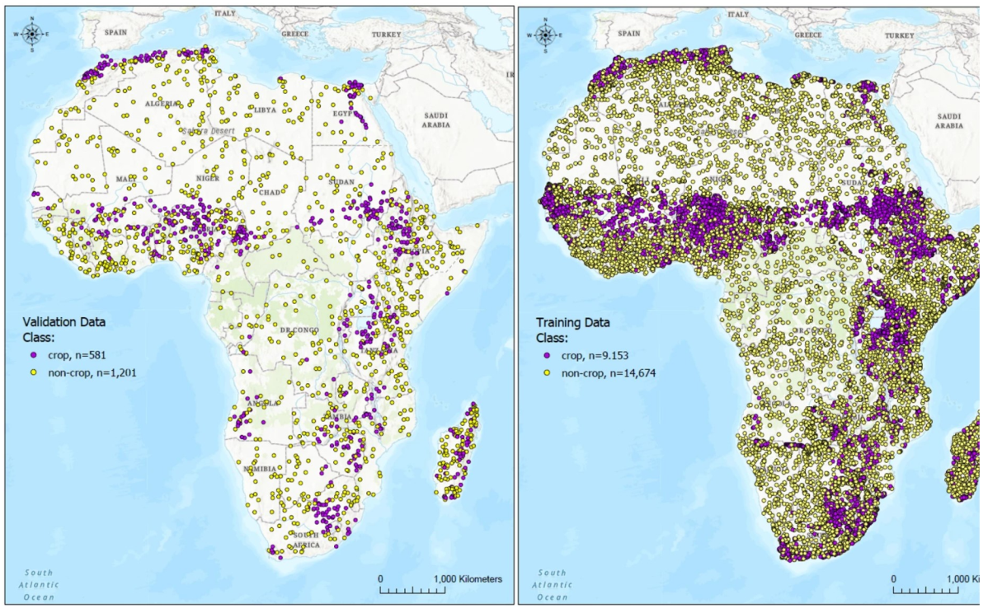

Figure 3: Locations used for training (right) and validation (left).

## Regressions

Another prominent use for ML algorithms is the prediction of continuous output variables from EO data. These regression approaches are used to estimate:

* biophysical and biochemical variables, e.g., leaf-area index, crop canopy temperature, above ground biomass (AGB, see Figure 4), chlorophyll content, nitrogen content, gross primary productivity, or crop-yields.
* geophysical variables, e.g., soil-moisture, soil-electrical conductivity

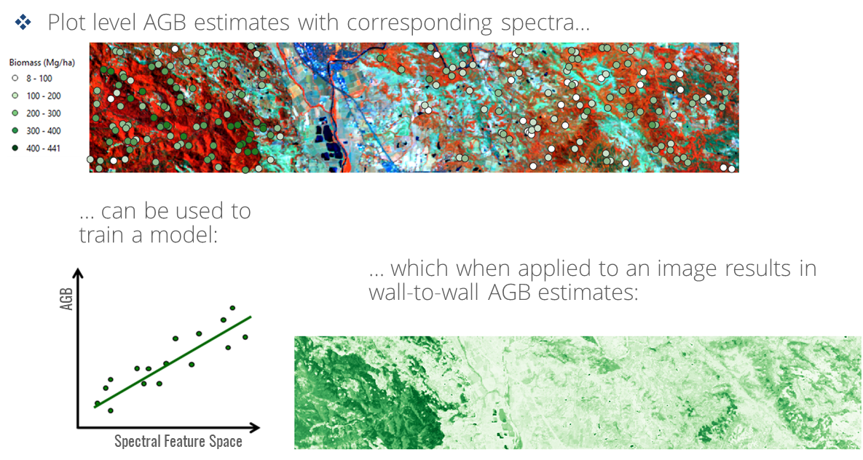

Figure 4: Prediction of above ground biomass using plot level AGB samples and hyperspectral remote sensing data. Source: Cooper et al. (2020). Mapping forest aboveground biomass with machine learning regression – Introductory slides https://eo-college.org/resource/retrieval-approaches-of-vegetation-traits-from-imaging-spectroscopy-data/

For example, the Global Forest Change project[6] maps loss and gain of forest for each 30m Landsat pixel over the entire globe. Trees are defined as vegetation with a height > 5m and *expressed as a percentage per output grid cell*. Forest Loss is defined as a stand-replacement disturbance, or a change from a forest to non-forest state. Forest Gain is defined as the inverse of loss, or a non-forest to forest change.

ML based regressions allow to predict fractions that sum-up to 100%. This “unmixing” of pixel fractions is often done with EO data from medium or coarse spatial resolution, like from Landsat (30m) or MODIS (300m). Typical outputs are land-cover fractions like „45% agriculture, 55% forests, 0% urban“, or a differentiation into fractions of “photosynthetic vegetation (PV)”, “non-photosynthetic vegetation (NPV)” and “open soil”.

Figure 6 shows how PV, NPV and soil fraction changed over time for a grassland in Germany. They help to better quantify effects of droughts or change in agricultural management.

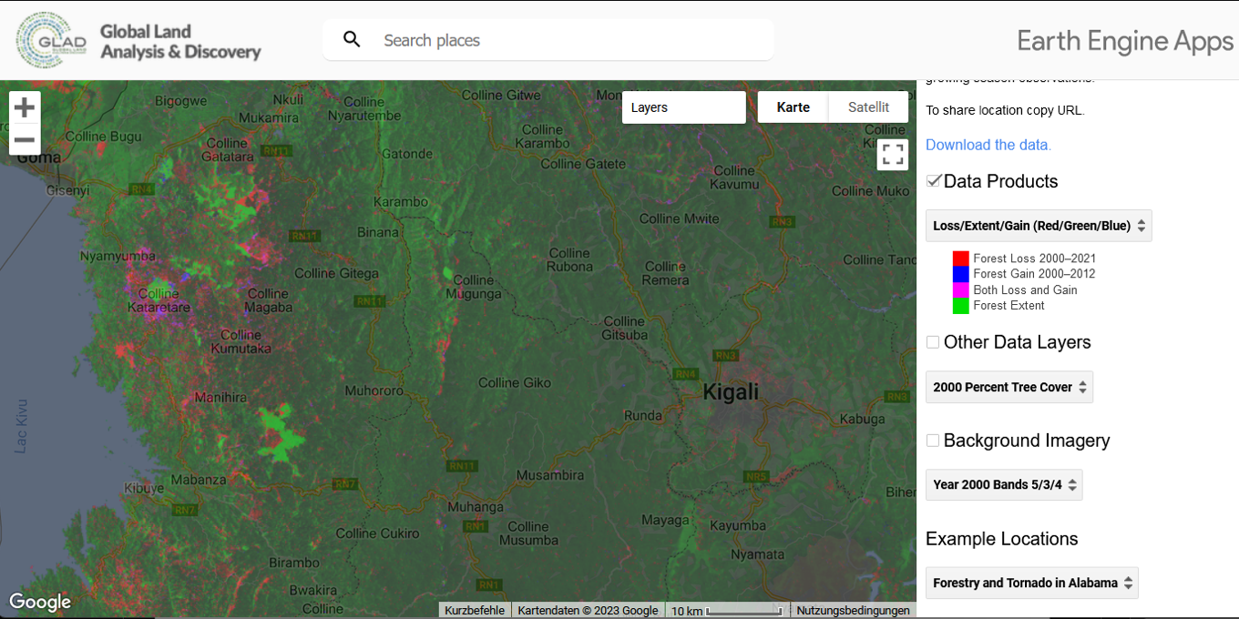

Figure 5: The Global Forest Change Map of Hansen et al. (2013). Source: <https://glad.earthengine.app/view/global-forest-change>

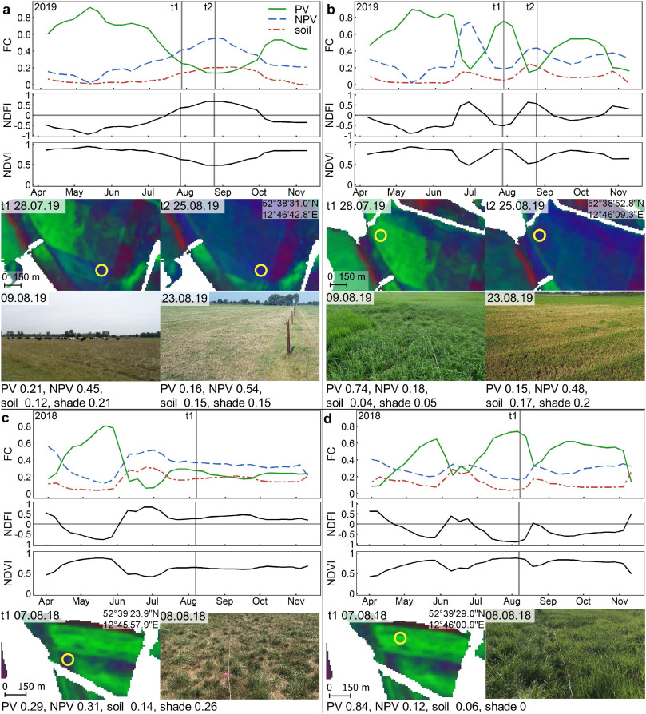

Figure 6: Effects of drought and grazing on a pasture in Germany. PV, NPV and soil fractions are derived from a Sentinel-2 time series. Source: Kowalski et al. (2022). Quantifying drought effects in Central European grasslands through regression-based unmixing of intra-annual Sentinel-2 time series. https://doi.org/10.1016/j.rse.2021.112781

## Clustering

The clustering of EO data groups pixels by feature similarity. They can support advanced exploratory data analysis (EDA, see Module 5) by highlighting statistical patterns across multiple data dimensions, that may be difficult to identify through visual interpretation only. The output of cluster algorithms is similar to the output of classifiers, as each pixel is labeled with a number relating to the cluster id. If in the following step each cluster gets a semantic meaning, e.g., by labeling it with a meaningful class name, this is also referred to as an *unsupervised classification*.

## Image Segmentation

The segmentation of remote sensing images may be considered as a special way of clustering. In addition to similar feature values, image segmentation accounts for spatial connectivity of neighbored pixels. Image segmentation is fundamental to geographic object-based image analysis. The classification of remote sensing images based on image segments, i.e., “semantic segmentation” avoids “salt-and-pepper effects” related to isolated pixels.

A common use case in agriculture is the delineation of crop fields. Particularly here, recent advances in deep learning have pushed the state-of-the-art, generally outperforming traditional approaches operating on image contrast. As such, field delineation has nearly reached operational stage in many regions of the world. It is noteworthy, however, that also the performance of ML-based field delineation varies quite strongly across regions. Particularly in smallholder agriculture, small fields, a large heterogeneity at the field and landscape level, as well as systematic shortage of reference data, make ML-based approaches underperform. Recent approaches based on transfer learning attempt to overcome these issues, for example used a model that was pre-trained with data from France and fine-tuned it with sparse labels in India[7].

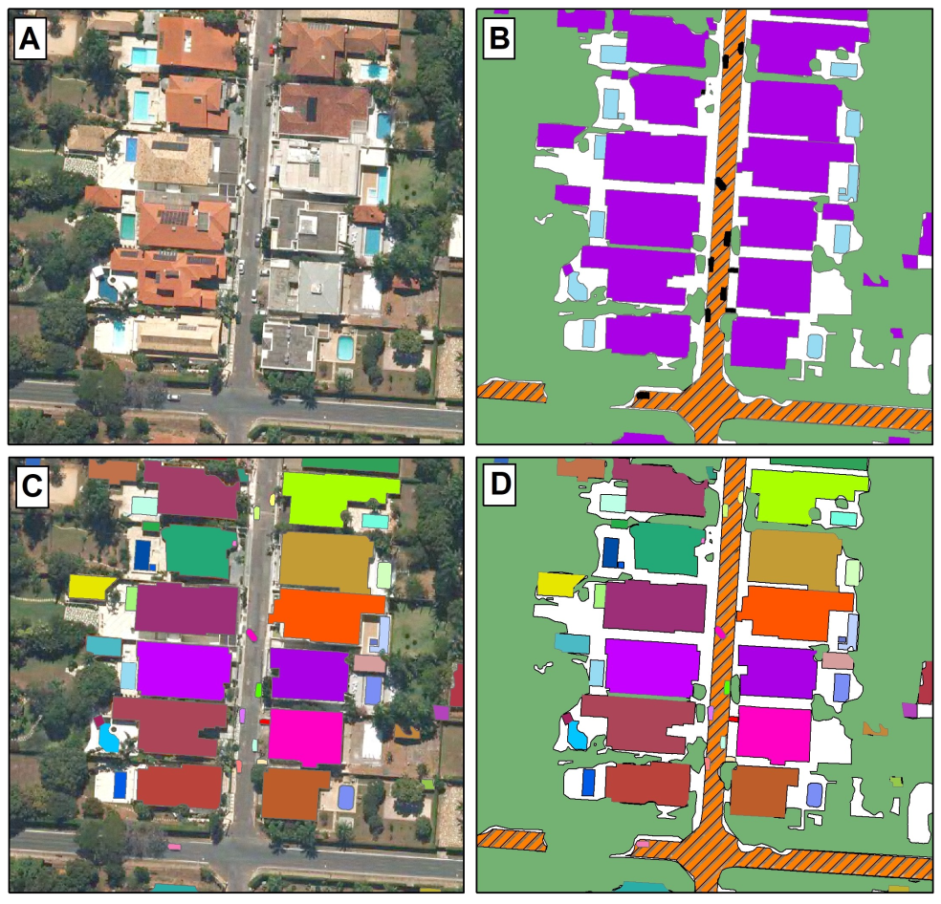

Figure 7: A) original image, B) semantic segmentation, C) instance segmentation, D) panoptic segmentation. Source: Carvalho et al. (2022): „Panoptic Segmentation Meets Remote Sensing“. https://doi.org/10.3390/rs14040965

You may be aware of the Segment-Anything-Model (SAM)[8] which has been shown to perform well on a variety of computer vision tasks, partly even outperforming pre-trained models. You can test it here: <https://segment-anything.com/demo>. Explorations on the use of SAM for various use-cases is ongoing, but first indications show, that SAM is not ready to use on EO data without further training[9].

## Interested in more exemplary use-cases?

The following open-access review publications give you a wider overview on how different ML approaches have been used in remote sensing:

* Maxwell et al. (2018) Implementation of machine-learning classification in remote sensing: an applied review. <https://doi.org/10.1016/j.isprsjprs.2019.04.015>
* Ma et al. (2019) Deep learning in remote sensing applications: A meta-analysis and review. <https://doi.org/10.1016/j.isprsjprs.2019.04.015>
* Alibabaei et al. (2022) - A Review of the Challenges of Using Deep Learning Algorithms to Support Decision-Making in Agricultural Activities. <https://doi.org/10.3390/rs14030638>
* Diaz-Gonzalez et al. (2022) Machine learning and remote sensing techniques applied to estimate soil indicators – Review. <https://doi.org/10.1016/j.ecolind.2021.108517>
* Mountrakis et al. (2011) Support vector machines in remote sensing: A review. <https://doi.org/10.1016/j.isprsjprs.2010.11.001>

# 6.2 Machine Learning methods & considerations specific to EO data

## Introduction

The integration of EO and machine-learning (ML) offers great potential for many real-world applications and is heavily researched in science and industry. A wealth of conventional machine learning and deep learning algorithms are applied in this field, with a handful of them being very well established. Generally, ML is great for EO applications, because mostly these models are non-parametric, do not superimpose assumptions on data distributions and are relatively robust in using high-dimensional input features. This is crucial when working with EO data containing different spatial, spectral, and temporal attributes. Many machine learning models are not challenged by multi-collinearity in the feature space.

We here briefly outline the most heavily used ML algorithms in the field of EO, namely Random Forests (RF), Support Vector Machines (SVM), and Convolutional Neural Networks (CNN). They all have their pros and cons. Random Forest are simple to understand, straight-forward to parametrize and efficient models being able to deal with high-dimensional feature space. Random Forest have several interesting features which facilitate hyper-parameter tuning or the assessment of classification uncertainty, which can be practical for guiding active-learning. SVM are efficient in separating classes with low inter-class variance by identifying a hyperplane in a non-linear and high-dimensional feature space. SVM can be parametrized using grid search. Both RF and SVM are applicable in both classification and regression tasks and are very efficiently trained based on pixel-level reference data which is cheaper to acquire. Training and deployment of RF and SVM models does not require a lot of computational resources, or GPUs. RF and SVM (typically) operate at the pixel-level, so they do not consider any spatial context in the predictions. This is where CNNs come into play. Deep CNNs have been changing the state-of-the-art in all kinds of computer-vision applications, where spatial context matters a lot. Different from the pixel-level algorithms, CNNs are extremely useful for semantic segmentation, instance segmentation, and object detection. Commonly, deep CNNs require a GPU for training and are trained with fully labeled image chips, although a lot of research is done to overcome this through, e.g., weak supervision, semi-supervised, or self-supervised learning. Importantly, transfer learning is key in the context of EO to overcome the very common reference data bottlenecks.

## Random Forest

### Basics

Developed by Leo Breimann[10], the Random Forest (RF) is likely the most heavily applied ML algorithm in the field of remote sensing, due to performance, robustness, computational efficiency, and straightforward parametrization.

RF are *ensembles* of self-learning decision trees (DTs), i.e., they integrate many decision trees to reach a final decision (prediction). Each decision tree consists of many nodes, which are split based on binary (true | false) rules until a conclusion can be reached. For EO data, a split rule could be NDVI > 0.32, separating pixels with higher, and lower values, respectively. The sequential branching creates a tree-like structure.

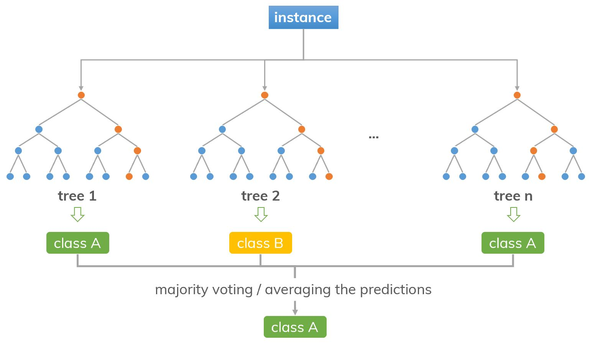

Figure 8: Schematic representation of the decision trees in a Random Forest and the voting procedure to obtain the final prediction. Source: https://dinhanhthi.com/random-forest/

Multiple decision trees - metaphorically speaking - make up a forest. The idea behind the ensemble component of RFs is that many weak learners can come to one strong decision (i.e., a strong ensemble model).

RF have two layers of randomness. First, they use *bootstrapping* i.e., picking a random subsample (with replacement) from the pool of training data for growing each individual DT. Second, to create each binary node/split, RFs only consider a random subset of the features to find the best feature-threshold combination. This split is determined by minimizing the Gini impurity index, which describes the homogeneity of the sub-populations resulting from each split[11].

### Predictions & probabilities

The RF classifier predicts the class label for a given data point through the majority vote of all individual trees. RF can also be applied for regressions, in which case the algorithm uses the mean of the predictions across trees. A given data point may receive different labels from individual trees. For instance, consider we have 500 trees: the same data point may be labeled as class “forest” by 380 trees, class “shrubland” by 75 trees, class “wetland” by 30 trees and class “cropland” by 15 trees. Based on the majority vote, the data point will be assigned the final class label “forest”.

It can be useful to analyze the information on the voting distribution in more detail. For instance, users can access the class-wise number of votes and standardize them into a probability, or classification confidence, more specifically. In the above example, 380 of 500 trees, or 76% of the trees voted for the class forest, make this prediction relatively certain. In other cases, the distribution of votes may be more balanced across classes and thus uncertain. The pixel-level probability scores are a useful feature of the RF, which can for instance be used in active learning to amend the training database by sampling from particularly uncertain regions or classes.

### OOB

By using only a portion of the training data for growing each tree, the RF algorithm can use the remaining training data to produce error estimates based on unseen data for each tree, which aggregate into the “out-of-bag” (OOB) error. The OOB can be useful for tuning the hyperparameters of the RF and gives an initial indication about the model performance. The OOB error should, however not be considered to be independent from the training process and thus does not substitute an independent validation using external reference data.

**Hyperparameters**

Depending on the implementation of the RF algorithm, users may have to determine suitable values for a number of hyperparameters. Most importantly, the number of trees and the number of features tried at each split. Generally, determining a suitable number of trees is straightforward. Increasing the number of trees generally decreases the error rate until it converges. From this point onwards, adding more trees to the RF does not improve the performance, but decreases the computation performance and is thus not needed. Using more than 200 trees is generally a good choice. The number of trees tried at each split is often defined relative to the number of features available to the model (e.g., square root of the number of features). It should not be too large to maintain the stochastic feature of the variable selection at each split, which decreases correlation between trees. The depth of the individual trees can be constrained through the number of levels in the tree (pruning), or through the minimum number of samples required to create a terminal node. Growing trees to the maximum depth can substantially increase in computation time.

You may wish to apply hyperparameter tuning using cross-validation in a grid search or random search layout[12],[13]. If you decide to go that route, please be aware of the abovementioned constraints on small number of trees (don´t trust a forest made of less than 100 trees, a large number of features tried at each split, and the depth of the trees).

## Support Vector Machines

### Basics

The naming *support vectors* are samples from the training data that are identified during the model training. For **support vector classification** (SVC) models, these support vectors define the location of the hyperplane margin (Figure 9) that separates the multi-dimensional feature space between different classes. The support vectors are found by maximizing the margin between different classes in the so-called “kernel space”.

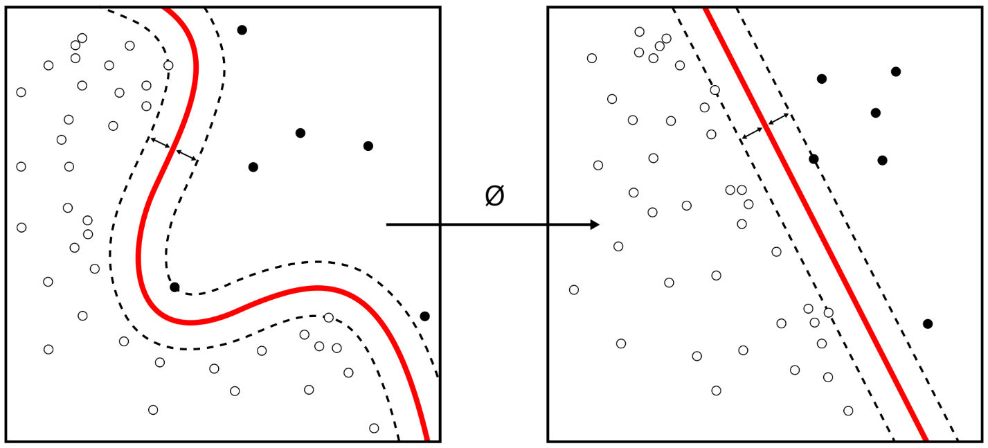

Figure 9: Hyperplane (red) and margin (dashed lines) of a Linear SVC in feature (left) and kernel (right) space. Data points on the margin are used as support.

We don’t need to understand the mathematics behind this kernel trick, but you should keep in mind that support vectors will be the data points, that are closest to the hyperplane. The most informative training data to parameterize an SVC model is therefore data from different classes but similar input features. It is therefore worth aiming more on a high diversity of input features instead of a high number of samples, e.g., when searching for training examples based on visual image interpretation. These samples can be found for example in transition regions, e.g., close to forest or crop-field boundaries[14],[15]. The search for such examples in image data can be supported by clustering the input data. Such a clustering is also helpful to focus fieldwork on areas for which reference data cannot be obtained easily by visual image interpretation.

In case of a **support vector regression** (SVR), support vectors define the “hyperline” that defines the values of a one-dimensional output variable from the multi-dimensional input values. The error-margin epsilon (ε) is the error that is tolerated to avoid model overfitting. The location of the hyperplane is found by minimizing the errors results from all other training samples that are still outside the error-margin. As for the SVC, this optimization is done in “kernel-space”.

### Model Training

SVMs are sensitive to non-standardized input data. It is therefore recommended to standardize the input features to have a mean = 0 and a standard deviation = 1. Don’t forget that such a scaling of input features needs to be done twice: for the input features that are used to train the SVM model, as well as on features that are later used as input to predict data[16].

In addition, the calibration of an SVM requires to choose these hyperparameters:

* a Kernel type, e.g., linear, polynomial RBF or sigmoid kernel and related parameters
* a value for the kernel regularization term C,
* in case of the SVR, a value for the error-margin (ε).

A suited combination of these values is often found by repeating the model training with different parameter combinations and testing the model performance using a cross-validation. Libraries like scikit-learn[17] provide tools and a good documentation how to perform the pre-processing of input features and find a suitable model parameterization.

## Convolutional Neural Networks

### Basics

Convolutional Neural Nets (CNN) are artificial neural networks heavily applied in ML for computer vision and are thus promising for EO applications. CNNs commonly feature a sequence of convolutional layers, which sequentially process the image and learn to recognize increasingly complex shapes and patterns from images. Few convolutional layers can be sufficient for simple tasks such as recognizing handwritten digits, while adding more layers enables CNNs to pick up complex objects, such as animal species or plant diseases.

The convolutional layers use kernels of predefined sizes (e.g., 3x3 pixels) to learn from images. The kernels contain randomly initialized weights which are learnable parameters. During model training, the kernel weights are updated and learn to pick up patterns in the image, like vertical lines or circular features. The outputs of the kernels are the result of a matrix multiplication and often fed into pooling operations, which aggregate the outputs and thereby decrease the width and height dimensions of the inputs.

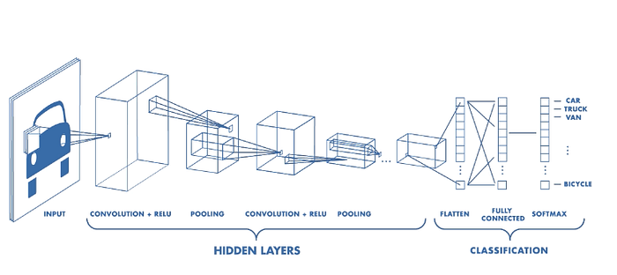

Figure 10 CNNs from <https://www.mathworks.com/videos/introduction-to-deep-learning-what-are-convolutional-neural-networks--1489512765771.html>

For illustrative purposes, the below figure depicts the process of passing one 3x3 kernel (dark blue) over a 4x4 image, yielding a 2x2 output. The arithmetic’s behind these operations are more complex in practice, as commonly convolutional layers involve multiple kernel filters which are applied over multiple images with multiple channels[18],[19],[20],[21].

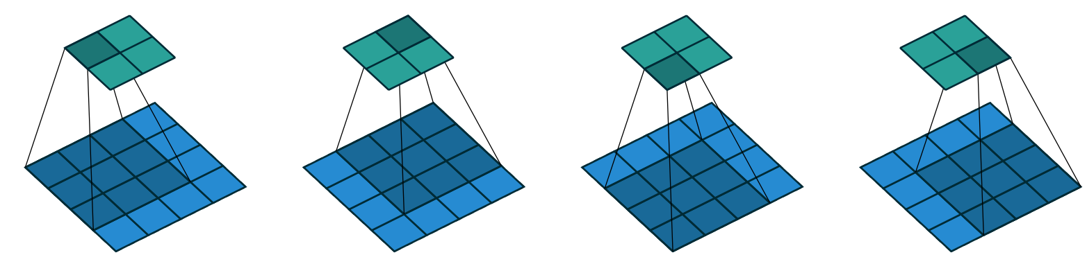

Figure 11 Schematic representation of a 3x3 kernel passing over a 4x4 input image, producing a 2x2 output. Figure from Dumoulin and Visin 2016 https://doi.org/10.48550/arXiv.1603.07285

The U-Net architecture[22] is a very commonly used for semantic segmentation. The name of this architecture comes from its U-shaped appearance. The architecture can be split into an encoder stage, producing lower-dimensional representations of the input images (in terms of width and height), as is typically done using CNN, followed by a decoder stage, which sequentially re-creates the original image dimensions using up sampling (or deconvolution) operations. Here, skip connections inform the network from where in the image a feature comes from. This is achieved by concatenating the outputs of the up sampling with the inputs of the opposite convolutional operation in the encoder. The skip connections enable the network to fully reconstruct the spatial detail of the input image[23],[24].

The basic idea of the U-Net provides the basis for further developments, such as U-Net++ (adding skip connections across encoder levels), Attention U-Net (adding attention mechanisms to skip connections), ResUNet (adding residual blocks similar to ResNet), and many many more.

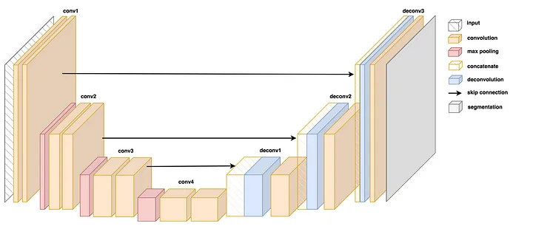

Figure 12 Schematic representation of the U-Net architecture indicating convolutions, max pooling operations in the encoder (left) and concatenation of opposing outputs with deconvolutions through skip connections in the decoder stage (right). Figure from https://towardsdatascience.com/u-net-explained-understanding-its-image-segmentation-architecture-56e4842e313a

## Challenges specific to EO data

Please be aware of common challenges when using EO data and reference data for EO applications:

### Earth observation data

Some global archives of satellite images and derived products are made freely available, such as MODIS or Landsat (NASA / USGS) or Sentinel-1 and Sentinel-2 (ESA). Still, there are a wealth of commercial data providers (Planet Labs, AirBus, Maxar) which operate satellites collecting very high-resolution imagery that may be suitable for your task. Such data may be costly, but often there are ways of obtaining samples of the data, access outdated data, or write a project proposal to obtain access.

Temporal revisit frequencies of the respective satellite systems, or cloud contamination may be a limiting factor for many applications, e.g., when the agricultural growing season is taking place during rainy periods. There are options to overcome such data scarce periods, e.g., by integrating radar data, such as Sentinel-1.

In EO data, you would often encounter high intra-class and low inter-class variance, e.g., in crop type mapping or field delineation. Sensor errors, geometric and radiometric quality issues may complicate analyses or render some of the data useless for your task. Many commercial very-high-resolution sensors such as PlanetScope cannot offer the same data quality as compared to the expensive public missions such as Landsat or Sentinel-2, so there are trade-offs involved.

EO data is big data, so consider substantial data storage requirements when designing your project and avoid duplicates of your data. Make use of cloud-based processing infrastructure wherever possible. Google Earth Engine offers free access to image catalogues and processing capacities for researchers.

### EO reference data

Most commonly, access to EO reference data is scarce and besides a few compiled benchmark datasets, one needs access to case-specific reference data suitable for use in a particular regional context and time period. You may realize that reference data availability (LULC, agriculture, etc.) is geographically biased. Typically, there is more data in high-income regions such as Europe or the US, and less data in low-income regions. Platforms like RadiantMLHub or Zenodo offer specialized EO datasets and are worth a look. Also, the <https://github.com/satellite-image-deep-learning/> repository offers a list of EO datasets open to the public.

Reference data on generic tasks such as land cover mapping can often be collected on screen, e.g., by using very-high resolution imagery contained in Google Earth. Always be reminded of the high requirements for timeliness and make sure image acquisition dates match your labels to avoid errors due to seasonal or inter-annual changes.

More specialized tasks, particularly in agriculture, require ground visits. This is the case, for instance for mapping crop types, or estimating yields.

The quality of training data will matter for your model[25]. Reference data for EO applications are often noisy, so take time to inspect the spatial, temporal, and thematic properties of the reference data and use the EDA techniques described in Module 5 to clean the data if needed. It can be useful to consider biases during collection in the field or by human annotators. Examples include subjectivity or lack of interpreter agreement[26].

## Performance evaluation

We motivated the section above by telling you about the real-world impact of ML4EO applications. While this is a great incentive to dive into the field, at least equally much it comes along with the responsibility of making sure to properly evaluate the products you are producing and to communicate the limitations of the outputs clearly. The EO community is actively working on defining good practices for assessing the quality of remotely sensed maps, and it is recommended to stick to these wherever circumstances allow it. Always remember: without an in-depth accuracy assessment, remotely sensed map products are just beautiful pictures.

Why this matters is easily understood. As an example, the deforestation monitoring systems for the Brazilian Amazon generate insights with legal implications for actual people on the ground. False positives in deforestation monitoring could cause the issuing of fines, which put the livelihoods of people like farmers on the ground at risk. Because of this, many double-safety nets and human evaluation is often part of such schemes. Other implications could be, for instance, that you use ML to generate advice for farmers on fertilizer application or irrigation scheduling, or you could send a team in the field to misclassified locations and thereby waste travel time, or human resources.

Following the good practice recommendations would, for most applications, allow you to better understand the distribution of errors across different regions, or points in time, or which classes are most likely to be confused with each other. This information is essential for downstream users of your products and prevents costly and frustrating experiences with EO-based maps.

In practice, the option space for quality assessment is often limited by the availability of reference data for the type of problem (e.g., LULC, crop types, yields) you are working on, and for the particular region and point in time. The more generic your task is, the more likely you are able to obtain existing reference data or collect new reference data through on-screen digitizing. This way, you can compile a reference database that fulfills the criteria needed for an independent validation. If you work on more specific problems, such as maize yield prediction in one Rwandan district for a past growing season, you have effectively no options to collect new reference data and are thus bound to the available data.

We can briefly outline good practices for the quality assessment of remotely sensed map products generated from classification-based and those generated from regression-based approaches.

### Classification

In the EO domain, typical metrics to report are Overall Accuracy (OA), User´s Accuracy (UA), Producer´s Accuracy (PA), or F1 score. While OA is a global metric, UA, PA, and F1 are class-wise metrics. UA and PA are equivalent to precision and recall, respectively. F1 is the harmonic mean of UA and PA. Moreover, confusion matrices are informative tools to better access and communicate the most common or relevant errors in your map and are thus commonly included when reporting results.

For classification, the best practice recommendations are to conduct an area-adjusted accuracy assessment[27],[28]. This involves generating a statistically representative sample across your study region and labeling a large number of sampling locations. This sample can be used to report Overall Accuracy, as well as class-wise User´s and Producer´s Accuracy including standard errors.

While this option is the gold standard, it may not be applicable to your specific use case. Whenever your reference data is constrained and you are not able to label any random location in your map product, k-fold cross-validation is a good option to conduct an accuracy assessment. Your reference data is divided into k subsamples of which k-1 are used for model training and the remaining part is used for testing. Doing this allows for reporting mean accuracy scores and a measure of variability (e.g., standard deviation or range).

### Regression

For regression problems, we aim at evaluating the correspondence between observed (reference data) and predicted quantities. Typical measures to report are root mean squared error (RMSE), mean absolute error (MAE), or comparing the linear agreement between observed and predicted quantities expressed as a linear regression model with intercept, slope, and R² as commonly reported metrics. Importantly, the observed data is the dependent and the predicted variable independent in this model specification.

A good linear fit would achieve a high R², an intercept close to 0, and a slope close to 1. For more detailed evaluation of biases and prediction quality, error metrics can also be generated for specific value ranges. This allows for an assessment of biases and variance, e.g., in lower or higher value ranges. The below figure illustrates this for observed versus modeled surface reflectance, but this could be done to check for saturation effects in higher value ranges for yield predictions, for instance. Often, the quantity of reference data is however limited, and such detailed investigations cannot be conducted.

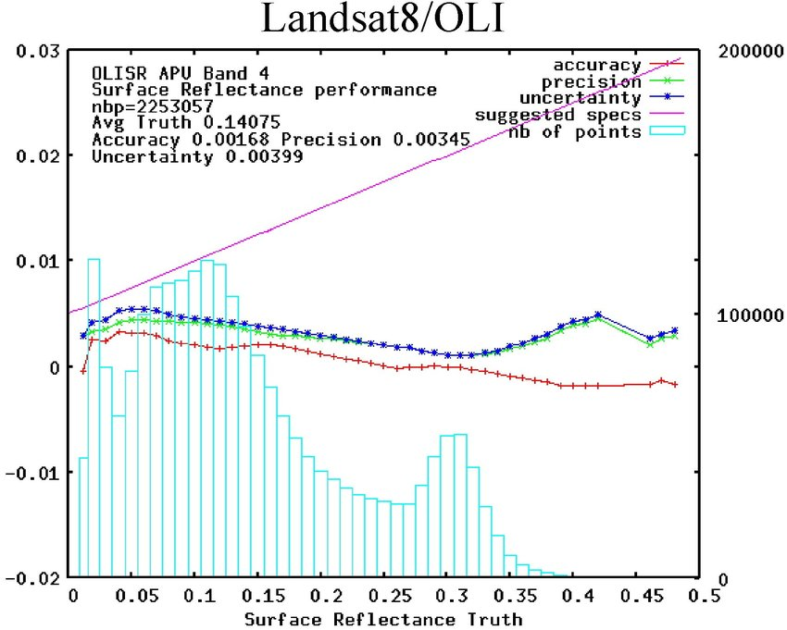

Figure 13: APU plot showing the accuracy, precision, and uncertainty of modeled surface reflectance across bins of measured surface reflectance.

### Object-level

Instance segmentation problems or other types of object delineation are typically evaluated using metrics describing the area or location agreement with reference data[29],[30]. Most commonly, the intersection over union (IoU), Dice index, as well as precision and recall are reported for area-based evaluation. Additional metrics include under-segmentation and over-segmentation. Be aware that some of these metrics are global, while others can be calculated at the object level, or the image level, depending on the application.

## Feature Selection

We normally expect that adding more features to an ML algorithm, e.g., additional spectral bands and spectral indices, does increase the provided information and therefore the model performance as well. However, it may lead to the opposite effect. Using a very high number of input-variables can also increase the performance of ML models[31]. Furthermore, a higher number of input variables obviously also increases the economic costs, e.g., because more data has to be downloaded, stored or processed.

You may therefore be interested in an ML model that can be run with a minimum set of input features, but still achieves a good model performance. Random Forests provide the “feature importance” metric, which is highest for input features that were selected most-often in the trained decision trees. Features with the lowest variable importance may therefore be skipped before we train the final RF model.

More generically, you can also use a feature selection to systematically assess the performance of any ML approach to select the subset of input variables that provides most information. A **forward-feature selection** starts with zero features and finds the one feature that maximizes the model performance when it is trained on this single feature. Once the most-important feature is selected, the procedure is repeated by adding the 2nd most important new feature and so on. A **backward-feature selection** starts with all input features and interactively removes the features that contribute the least information.

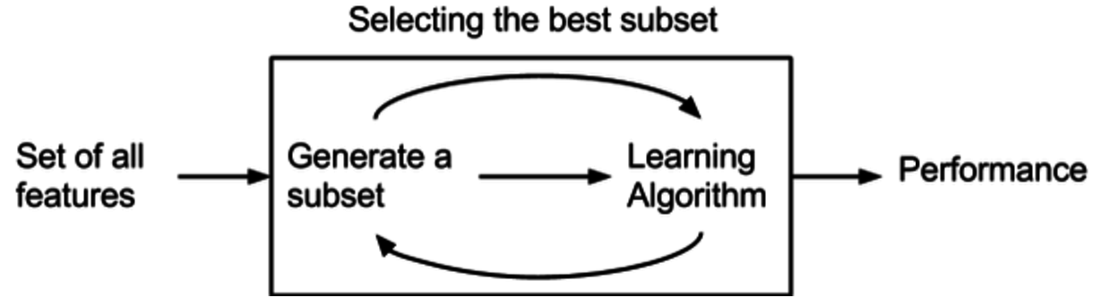

Figure 14: A feature selection assesses the model performance for subsets of the input features. Source: https://prwatech.in/blog/machine-learning/feature-selection-tutorial/

# 6.3 Transfer learning (summary of popular open-source models available for fine tuning)

## Introduction

Transfer learning is widely used in EO applications. The reasons for this stem from: 1) the commonly limited availability of task-specific labels for EO applications that would allow for training from scratch; 2) substantial reduction in compute gained by avoiding training a base model on a large image dataset, and 3) gains in model performance over training from scratch.

A comparison of model performance across manifold backbone architectures and LULC benchmark datasets reveals the benefits of transfer learning over training from scratch. The figure below shows a large number of experiments using different architectures and benchmark datasets for LULC classification, with performance of pre-trained models almost always exceeding the performance of models trained from scratch.

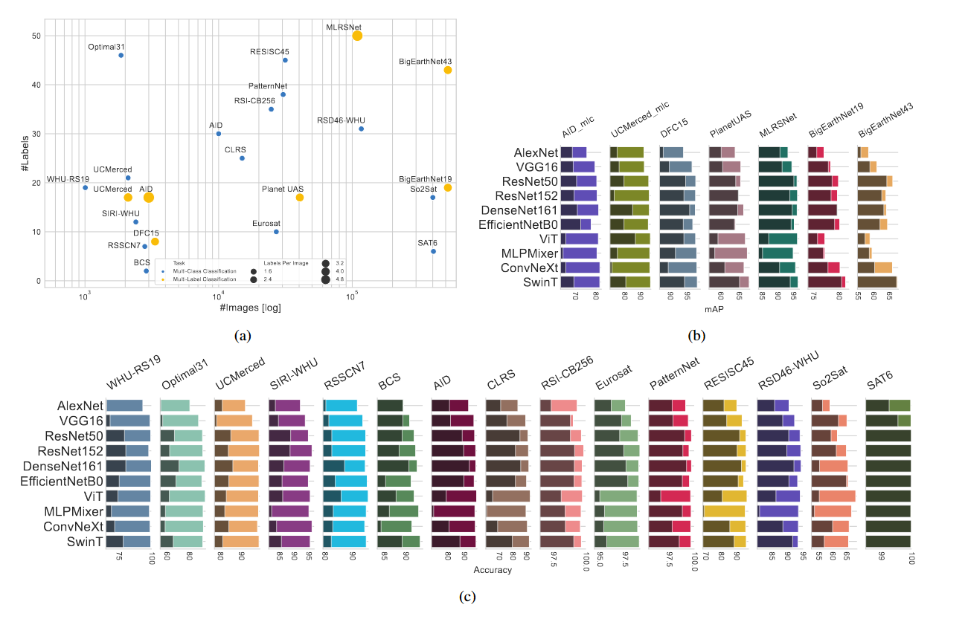

Figure 15 Comparison of model architectures for image classification (not semantic seg) across large EO benchmark datasets (a). Performance of models pre-trained with ImageNet-1k (lighter shading) exceeds performance of models trained from scratch (dark shading) throughout in (b) multi-label and (c) multi-class classification tasks.Fig. from Dimitrovski et al. 2023 https://doi.org/10.1016/j.isprsjprs.2023.01.014

## Pre-trained models

A large number of computer vision encoders (backbones) with different properties are available for use in the common ML frameworks like TensorFlow or PyTorch. Pre-trained weights are in most cases generated from training with ImageNet, or variants thereof.

The TensorFlow semantic segmentation model library includes 4 popular model architectures which can be complemented with 25 different backbones trained on ImageNet[32]. The PyTorch semantic segmentation model library includes 9 model architectures and 124 different backbones[33].

The pre-trained encoders differ in relation to trade-offs between performance and complexity. Typically, users would tend to favor slim backbones such as ResNet34 (21M parameters) over their complex counterparts, such as ResNet152 (58M parameters) or use variants optimized for constrained computational resources but slightly lower performance, such as MobileNet.

Some of the most popular backbones for semantic segmentation are VGG, ResNet, MobileNet, and Inception, but there are also EO-specific pre-trained models for generic or specific applications.

### Visual Geometry Group (VGG)

VGG encoders combine small convolutional filters (3x3 convolutions) with max-pooling layers for downsampling. The architectures are comparatively simple but deep, with the most complex implementation having 19 layers (VGG19). VGG can thereby learn complex and fine-grained features in the image and yield good performances. VGG encoders were found to generalize well across a variety of tasks in semantic segmentation or object detection. As an example, pre-trained VGG16 encoders have been used for field delineation in smallholder agriculture[34].

### Residual Net (ResNet)

ResNet encoders are deep neural networks with different variants having fixed amounts of layers including 18, 34, 50, 101, or 152. ResNets involve skip connections to overcome issues with vanishing gradients which are particular to very deep neural networks. ResNet encoders perform very well in image segmentation, object detection, and image classification. In the context of EO image classification, for example, pre-trained ResNet-50 encoders have outperformed VGG16[35].

### MobileNet

MobileNet encoders are suitable for resource-limited devices. Also here, simple, and complex variants exist, which differ with regard to the number of parameters. Regarding performance, MobileNetV3-Large can be a viable replacement of ResNet50 for users who are willing to sacrifice a bit of accuracy for a roughly 6x speed-up. MobileNet-V3 was for example used for water body detection, outperforming ResNet-50 and EfficientNet-B4[36].

### **Inception**

Also known as GoogLeNetv3, Inception_V3 is using multi-scale feature extraction by applying kernels of different sizes in parallel and use 1x1 convolutions to reduce the number of input features for larger convolutions, which makes it computationally efficient. Inception_V3 is versatile and can be used in classification, object detection, and semantic segmentation, and is implemented, amongst others, in PyTorch[37].

### **Task-specific encoders for EO**

Besides such generic computer vision models, you can also make use of a wealth of models pre-trained for EO-specific tasks, such as pre-trained models for field delineation in India based on SPOT6/7 data[38] or a Transformer-encoder which was trained on unlabeled Sentinel-2 time series using self-supervision[39]. We would like to motivate you to experiment with ML for EO. To get you started, access to labeled data is likely a good first step. You can find a variety of useful materials for the context of EO applications (including a comprehensive list of datasets, interesting papers, code repositories, and pre-trained models)[40],[41].

## EO-specific considerations for fine-tuning

Please take note of the following considerations that are particular to EO data when working with Transfer Learning.

### Fine-tuning techniques

When fine-tuning models with EO data, you can make use of the common suite of techniques to improve the training procedure, such as freezing layers, applying adaptive learning rates, early stopping, etc. GPU RAM can be a constraining factor, so try to keep batch sizes small for testing (e.g., bs = 4) and increase depending on the available resources.

### **Input data dimensions**

Pre-trained computer vision models may be trained on single RGB image chips. EO data may come with different dimensions due to their **spectral** and **temporal** properties. EO data can have spectral bands beyond the typical RGB channels and be available for several points in time. For instance, PlanetScope 4-band data with RGB and a near infrared channel, or Sentinel-2 13-band data including multiple bands in near and shortwave infrared and with varying spatial resolutions. Time series may be available, although often these are not equidistant (i.e., irregular intervals between acquisitions due to orbital constellations or cloud contamination).

Pre-trained models thus require that new inputs come with the number and size of dimensions as the source data used for training the model from scratch. Typically, this is W x H x C (width x height x channels) with H, W = 256 and C = 3 for 256 x 256 pixel RGB images. Remote sensing data, on the other hand may have C = 4 and feature additional dimension T (time). There are a handful of alternatives to deal with this issue.

* Passing time series or multispectral stacks through 1x1 convolutions to obtain 3-band inputs for the pre-trained encoders, for instance, in the Spatio-Temporal U-Net[42].
* You can add randomly initialized weights for additional channels[43]. The pre-trained segmentation models in PyTorch allow for specifying an arbitrary number of input bands, where weights from initial convolutions would be reused[44].
* Using customized architectures: For example, the MSNet architecture splits 6-channel multi-spectral data into two sets of 3-band images which are fed to individual backbones and concatenates the outputs in the decoding stage[45].
* For time series applications, one can generate consensus across multiple predictions representing different points in time is a straight-forward option as well[46]. Predicted class probabilities could for example simply be averaged across time steps to obtain a consensus prediction.

### **Distribution shift**

Distribution shift is quite prevalent in EO problems. Target classes may vary geographically, for example the size and structure of crop fields are striking when comparing across regions. The below figure from Wang et al. (2022) illustrates the pronounced differences in field size between France and India.

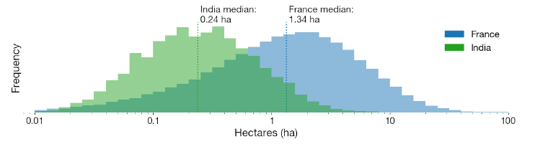

Figure 16 *Histograms of field areas on a log x-axis show that France fields are on average 5.6 times larger than India fields*

Adding to that, there is commonly a high temporal variability. A crop field changes appearance from bare open soil to a dense vegetation canopy, and after harvest again represents bare open soil within the course of a few months. Specific crops, such as paddy rice may seasonally appear similar to shallow water surfaces. It is therefore important to have good control over the acquisition timing of the EO data used and be aware that predictions on unseen seasons may well underperform.

Moreover, sensor-specific characteristics and pre-processing of EO data (see Module 5) may affect how targets appear in the data. When using transfer learning, you should for instance select data with appropriate spatial resolution for the specific task. For example, using Landsat data for crop type mapping in smallholder agriculture is going to be challenging in many instances, as the pixel size of 900m² is too coarse to capture the heterogeneity on the ground. Using different spectral bands or indices, as well as different pre-processing routines may further alter the distribution of your input data values as compared to the pre-trained models.

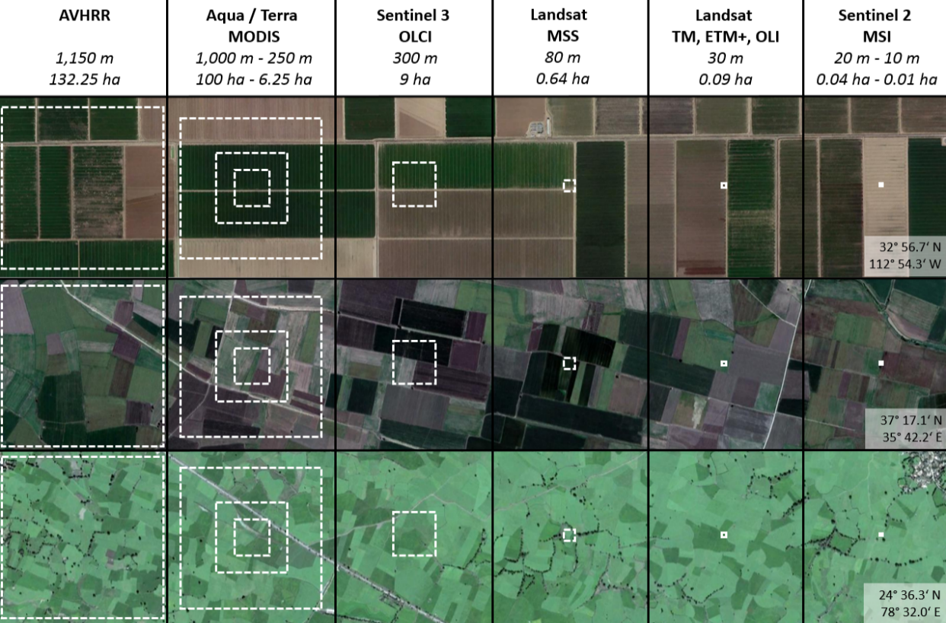

Figure 17 Spatial resolution of operational satellite missions from coarse to fine-grained in agricultural landscapes in the United States (top), Turkey (middle), and India (bottom). Image data obtained from Digital Globe, Google Earth.

### Value range and normalization

Matching the normalization of pre-trained models requires the image statistics of the underlying training datasets (e.g., ImageNet). Moreover, EO data may be scaled differently than conventional RGB images (8-bit data type, value range 0-255). Surface reflectance is naturally expressed in decimal values (Float32 data type, value range 0-1), but common conventions exist, for instance the use of scaling factors for reducing data storage capacity (i.e., storing images as Int16 data types, value range 0-10,000). You should be aware of the expected value range when using pre-trained models and take care of normalization.

### Data augmentation

Standard data augmentation routines in EO data include brightness modifications, contrast enhancement or reduction, blurring, random rotations, and horizontal / vertical flips of the images. There is no correct orientation in remotely sensed imagery (different from natural photographs). Target classes may be located at any position in the image.

### Multi-spectral data & time series

Multiple studies report improved performance when including spectral information[47] or time series[48],[49],[50]. Please note that the added value of multi-spectral data (or the use of additional indices) or time series over mono-temporal RGB images can be quite task- or context-specific. For example, time series information is very important in the context of crop type mapping, but likely less so for building outline detection.

## Wrap-up

Summing this up, we strongly encourage you to test your ideas. There are many open questions left, e.g., on the use of spectral bands, time series, how to mitigate some of the challenges pertinent to EO data, such as cloud contamination, sensor errors, etc. So, there are plenty of opportunities to experiment with EO in ML!

1. Digital Earth Africa <https://maps.digitalearth.africa>
2. Copernicus DEM – Global and European Digital Elevation Model. <https://spacedata.copernicus.eu/collections/copernicus-digital-elevation-model>
3. Funk et al. (2015) The climate hazards infrared precipitation with stations—a new environmental record for monitoring extremes <https://doi.org/10.1038/sdata.2015.66>
4. ESA Copernicus Open Access Hub <https://scihub.copernicus.eu>
5. See [https://docs.digitalearthafrica.org/en/latest/data_specs/Cropland_extent_specs.html#Specifications](https://docs.digitalearthafrica.org/en/latest/data_specs/Cropland_extent_specs.html%23Specifications)
6. Hansen et al. (2012) High-Resolution Global Maps of 21st-Century Forest Cover Change <https://doi.org/10.1126/science.1244693>)
7. Wang et al. (2022) Unlocking Large-Scale Crop Field Delineation in Smallholder Farming Systems with Transfer Learning and Weak Supervision <https://doi.org/10.3390/rs14225738>
8. Segment Anything Research by Meta AI <https://segment-anything.com/>
9. Ren et al. (2023) Segment anything, from space? <https://doi.org/10.48550/arXiv.2304.13000>
10. Lei Breiman (2001) Random Forests. <https://doi.org/10.1023/A:1010933404324>
11. Yiu (2019) Understanding Random Forest <https://towardsdatascience.com/understanding-random-forest-58381e0602d2>
12. Koehrsen (2018) Hyperparameter Tuning the Random Forest in Python <https://towardsdatascience.com/hyperparameter-tuning-the-random-forest-in-python-using-scikit-learn-28d2aa77dd74>
13. Rosebrock (2021) Introduction to hyperparameter tuning with scikit-learn and Python <https://pyimagesearch.com/2021/05/17/introduction-to-hyperparameter-tuning-with-scikit-learn-and-python/>
14. Mathur & Foody (2008): Crop classification by support vector machine with intelligently selected training data for an operational application, <https://doi.org/10.1080/01431160701395203>
15. Foody & Mathur (2006): The use of small training sets containing mixed pixels for accurate hard image classification: Training on mixed spectral responses for classification by a SVM. <https://doi.org/10.1016/j.rse.2006.04.001>
16. Scikit-learn documentation. 6.1. Preprocessing data [https://scikit-learn.org/stable/modules/preprocessing.html#preprocessing](https://scikit-learn.org/stable/modules/preprocessing.html%23preprocessing)
17. scikit-learn. Machine Learning in Python <https://scikit-learn.org>
18. Dumoulin and Visin (2016) A guide to convolution arithmetic for deep learning <https://doi.org/10.48550/arXiv.1603.07285>
19. Deep AI Convolutional Neural Network <https://deepai.org/machine-learning-glossary-and-terms/convolutional-neural-network>
20. Pokharna (2016) The best explanation of Convolutional Neural Networks on the Internet! <https://medium.com/technologymadeeasy/the-best-explanation-of-convolutional-neural-networks-on-the-internet-fbb8b1ad5df8>
21. Mishra (2020) Convolutional Neural Networks, Explained <https://towardsdatascience.com/convolutional-neural-networks-explained-9cc5188c4939>
22. Ronneberger et al. (2015): U-Net: Convolutional Networks for Biomedical Image Segmentation. <https://doi.org/10.48550/arXiv.1505.04597>
23. O’Sullivan (2023) U-Net Explained: Understanding its Image Segmentation Architecture- <https://towardsdatascience.com/u-net-explained-understanding-its-image-segmentation-architecture-56e4842e313a>
24. Zhang (2019). UNet — Line by Line Explanation <https://towardsdatascience.com/unet-line-by-line-explanation-9b191c76baf5>
25. Elmes et al. (2020) Accounting for Training Data Error in Machine Learning Applied to Earth Observations <https://doi.org/10.3390/rs12061034>
26. Estes et al. (2022) High Resolution, Annual Maps of Field Boundaries for Smallholder-Dominated Croplands at National Scales <https://doi.org/10.3389/frai.2021.744863>
27. Olofson et al. (2014) Good practices for estimating area and assessing accuracy of land change <https://doi.org/10.1016/j.rse.2014.02.015>
28. FAO (2016) Map Accuracy Assessment and Area Estimation: A Practical Guide <https://www.fao.org/documents/card/en/c/e5ea45b8-3fd7-4692-ba29-fae7b140d07e>
29. Clinton et al. (2010) Accuracy Assessment Measures for Object-based Image Segmentation Goodness. <https://doi.org/10.14358/PERS.76.3.289>
30. Zhan et al. (2005) Quality assessment for geo‐spatial objects derived from remotely sensed data <https://doi.org/10.1080/01431160500057764>
31. Altman et al. (2018) The curse(s) of dimensionality <https://doi.org/10.1038/s41592-018-0019-x>)
32. Segmentation Models’s documentation <https://segmentation-models.readthedocs.io/en/latest/tutorial.html>
33. segmentation-models-pytorch <https://pypi.org/project/segmentation-models-pytorch/>
34. Persello et al. (2019) Delineation of agricultural fields in smallholder farms from satellite images using fully convolutional networks and combinatorial grouping <https://doi.org/10.1016/j.rse.2019.111253>
35. Naushad et al. (2021) Deep Transfer Learning for Land Use and Land Cover Classification: A Comparative Study <https://doi.org/10.3390/s21238083>
36. Wieland et al. (2023) Semantic segmentation of water bodies in very high-resolution satellite and aerial images <https://doi.org/10.1016/j.rse.2023.113452>
37. PyTorch. Inception_v3 <https://pytorch.org/hub/pytorch_vision_inception_v3/>
38. Wang et al. (2022) 10,000 Crop Field Boundaries across India <https://doi.org/10.5281/zenodo.7315090>
39. SITS-Former: A Pre-Trained Spatio-Spectral-Temporal Representation Model for Sentinel-2 Time Series Classification <https://github.com/linlei1214/SITS-Former>
40. satellite-image-deep-learning <https://github.com/satellite-image-deep-learning/>
41. Hoeser and Kuenzer (2020) Object Detection and Image Segmentation with Deep Learning on Earth Observation Data: A Review-Part I: Evolution and Recent Trends <https://doi.org/10.3390/rs12101667>
42. Aung et al. (2020) Farm Parcel Delineation Using Spatio-temporal Convolutional Networks. <https://doi.org/10.1109/CVPRW50498.2020.00046>
43. Persello et al. (2019) Delineation of agricultural fields in smallholder farms from satellite images using fully convolutional networks and com-binatorial grouping. <https://doi.org/10.1016/j.rse.2019.111253>
44. segmentation-models-pytorch 0.3.2 <https://pypi.org/project/segmentation-models-pytorch/>
45. Tao et al. (2022) MSNet: multispectral semantic segmentation network for remote sensing images <https://doi.org/10.1080/15481603.2022.2101728>
46. Waldner et al. 2020 Deep learning on edge: Extracting field boundaries from satellite images with a convolutional neural network. <https://doi.org/10.1016/j.rse.2020.111741>
47. Naushad et al. (2021). Deep Transfer Learning for Land Use and Land Cover Classification: A Comparative Study. <https://doi.org/10.3390/s21238083>
48. Aung et al. (2020) Farm Parcel Delineation Using Spatio-temporal Convolutional Networks. <https://doi.org/10.1109/CVPRW50498.2020.00046>
49. Waldner et al. 2020 Deep learning on edge: Extracting field boundaries from satellite images with a convolutional neural network. <https://doi.org/10.1016/j.rse.2020.111741>
50. Tarasiou et al. (2023) ViTs for SITS: Vision Transformers for Satellite Image Time Series <https://doi.org/10.48550/arXiv.2301.04944>